**Spring Boot API with Angular UI**

This example app shows how to create simple a Spring Boot API and display its data with an Angular UI

The home ( first) page shows all active tasks

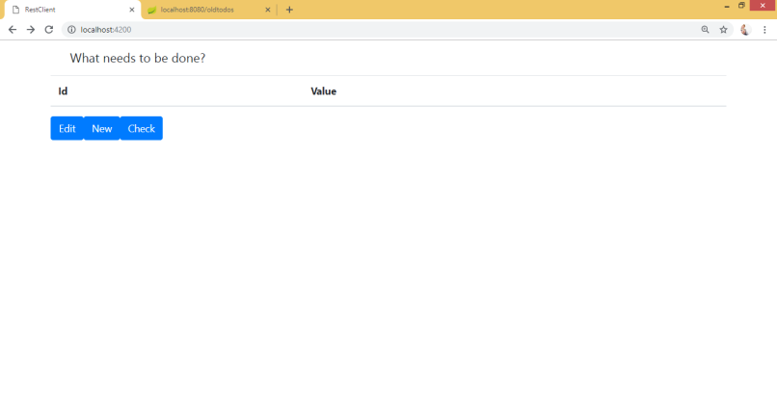

Please note, that in order to create new task, you should press New (button). In order to edit task, please press Edit (button). When you press Edit or new you will be redirected to new page

In order to check done task, please press check buttton

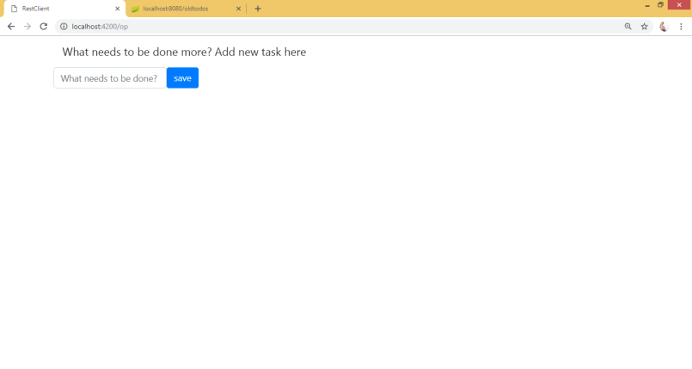

I